LGE Internal Use Only

LGE VS [OEM NAME] [PROJECT NAME]

SysTP (System Test Plan)

About This Template
- Template Name: LGE_VS_SysT_T02_SysTP(System Test Plan)
- Management Department: VS SW Process Team
- Revision History
Version | Date | Comment | Author
2.0 | 2017-10-16 | Initial Release  - Modified from LGE_VC_Template_TMP(Test_Master Plan_v1.0 to comply with A-SPICE 3.0 and ISO 29119 | VC Smart SW Process Team  LG Electroincis
2.1 | 2019-03-08 | Update due to annual organization restructuring (VC --> VS) | VS Smart SW Process Team
2.2 | 2021-08-06 | Updated security notice of this template (Before: LGE Confidential->After: LGE Internal Use Only)  Security level related note (the last sentence in red color below) | VS Smart SW Process Unit

Read me first
- This template is the default form for “SysTP (System Test Plan)“ document, which consists of the writing guidelines(green box) and examples.
- Before writing this document, read and keep in mind the contents of “General Guidelines”.
- Once you have finished to write a document, delete all writing guidelines(green box).
- The contents of this template may not be 100% correct for all projects, so writers should use it after tailoring the contents to the project size and characteristics.
- In test domain, the term “Item” is used. So, the term “Element” and “Component” should not be used.
- The notice “LGE Internal Use Only” is for this template itself. The document which use this template needs to be classified as suitable security level according to its content.
- 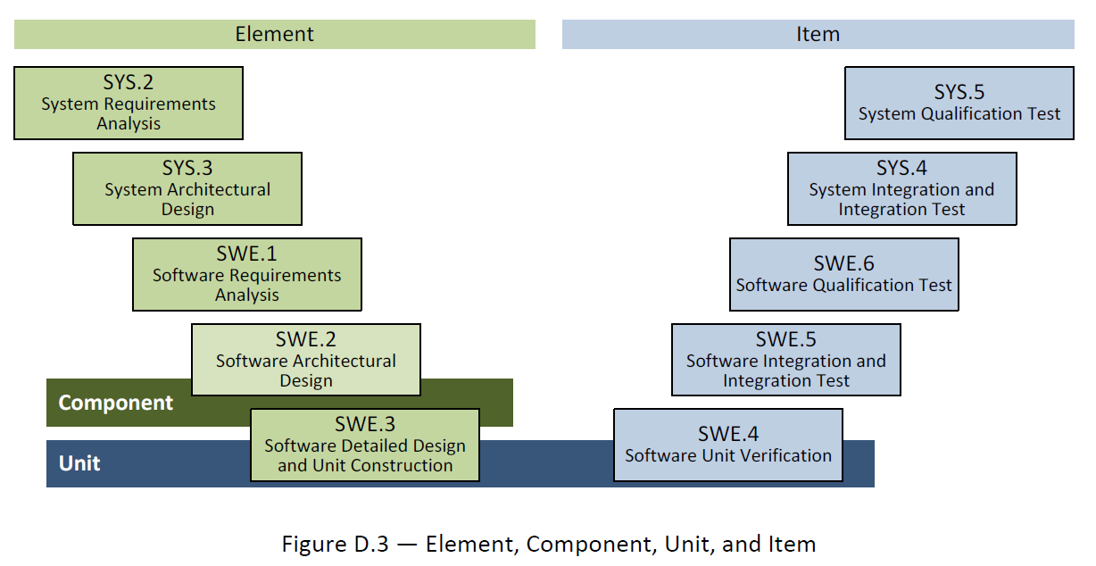

General Guidelines
- Ground Rules for SysTP
- The system qualification test plan for each test area is to verify each development area. The test target and criteria of the test area are planned based on the corresponding development area.
- Depending on the project situation, SysTP should be tailored under consultation with relevant stakeholders.
- Seven Rules
- Write in the reader's perspective.
- Avoid unnecessary repetition of information in the document.
- Make sure there is no ambiguity in the document. Explicitly specify the meaning of the notations used in the diagram.
- Use the standard structure of the document. Make a structure that is easy to refer to. Mark areas that are difficult to define as "to be determined" instead of leaving them blank.
- Record the rationals for adopting the specific test. This is useful for future review or modification.
- Do not immediately reflect changes in the document. Instead, reflect them by the document's version control and release schedule.
- Ask audiences for a review.
- References
This template has been revised by referring to the following test related technical data and the TMP template and guidance document which have been distributed in the past.
- Automotive_SPICE_PAM_v3.0
- ISO/IEC/IEEE 29119 Software Testing Standard
- ISO/IEC/IEEE 25010:2011 Systems and Software Engineering
- Previously deployed TMP templates and guidelines of VS Smart Division
- Document Format
If you use this template, you do not have to worry about document format. The following basic rules should be observed.
- Font : Clear Gothic
- Give numbers and titles to all pictures and tables and make them easy to be refered.
- Caption Add : [Menu of MS Word] > [Reference] > [Add Caption] > [Lable] > Select “Figure” or “Table” and click “OK” button
- Caption Location
Insert caption below “Picture” : Figure 1 Picture Title, Figure 2 Picture Title, …
Insert caption above “Table” : Table 1 Table Title, Table 2 Table Title, …
- Document Versioning, File Naming Rule
See "Naming Conventions for Document Work Products" in the Configuration Management Guidelines (LGE_VS_Guideline_ Configuration Management) maintained within the project.

About This Document
Document Information
Issuing authority | VS OOOO Team
Configuration ID | Configuration Item ID of CMBook
Status of document | In Progress / Approved / Released

Revision History
Write the Revision History. Make sure the latest content is at the top.

Verion | Date | Comment | Author | Approver
#.# | YYYY-MM-DD | OOOOOOO | OOO | OOO

Purpose
Write about the purpose of this document.
This document is the System Integration Test plan of the [project name] project.
Scope
Write the scope of this document.
This document contains the following:
- Strategy, Scope, Quality Goal, Role and Responsibility, Methodology, Schedule, Deliverables, Measurement, Regression Test, Criteria, Environment, Constraint, Risk
Audience
Write the audience for this document.
The audiences of this document are as below:
- Project Manager, Project Leader, Project Sub-leader, SW Engineer, HW Engineer, Test Engineer, Configuration Manager, Requirement Manager

Related Documents
Write documents related to the use of this document.
The related documents of this document are as below:
- LGE_[OEM]_[Project Name]_TMP
- LGE_[OEM]_[Project Name]_SWUTP
- LGE_[OEM]_[Project Name]_SWITP
- LGE_[OEM]_[Project Name]_SWTP
- LGE_[OEM]_[Project Name]_SysITP
- LGE_[OEM]_[Project Name]_SysTP
- LGE_[OEM]_[Project Name]_SWUTC
- LGE_[OEM]_[Project Name]_SWITC
- LGE_[OEM]_[Project Name]_SWTC
- LGE_[OEM]_[Project Name]_SysITC
- LGE_[OEM]_[Project Name]_SysTC
- LGE_[OEM]_[Project Name]_PMP
- LGE_[OEM]_[Project Name]_CMP
- LGE_[OEM]_[Project Name]_CMBook
- LGE_[OEM]_[Project Name]_WBS
- LGE_[OEM]_[Project Name]_PRM

Conventions and Acronyms
Conventions
Indicate the helpful and important information as below:

NOTE
Helpful Notes

CAUTION
Important Information

Acronyms
Acronym | Description
TMP | Test Master Plan
SysTP | System Qualification Test Plan
SysT | System Qualification Test
SysITP | System Integration Test Plan
SysIT | System Integration Test
SWTP | Software Qualification Test Plan
SWT | Software Qualification Test
SWITP | Software Integration Test Plan
SWIT | Software Integration Test
SWUTP | Software Unit VerficiationPlan

Table of Contents
1 Plan Context 1-1
1.1 Test Item 1-1
1.2 Test Scope 1-1
1.3 Functionality 1-2
1.4 Non-Functional Quality Attributes 1-3
2 Risk Register 2-4
2.1 Project Risks 2-4
2.2 Product Risks 2-4
3 Test Strategy 3-6
3.1 Test Process 3-7
3.2 Test Deliverables 3-7
3.2.1 Test Cases 3-7
3.2.2 Test Results Report 3-7
3.2.3 Test Plan 3-8
3.3 Reviews 3-8
3.3.1 Testability Review 3-8
3.3.2 Test Case Conformity Review 3-9
3.4 Test Design Techniques 3-9
3.4.1 Specification Based Testing 3-9
3.4.1.1 Equivalence Partitioning (Example) 3-10
3.4.1.2 Boundary Value Analysis (Example) 3-10
3.4.2 Experience Based Testing 3-10
3.5 Test Entry/Completion Criteria 3-11
3.5.1 Entry Criteria 3-11
3.5.2 Completion Criteria 3-11
3.6 Metrics to be collected 3-11
3.6.1 The Metrics of Measurement Analsysis 3-11
3.6.1.1 Statement Coverage (Example) 3-11
3.6.2 The Metrics of Test Cases Develoment Plan 3-12
3.7 Retesting and Regression Testing 3-12
3.8 Test Data 3-12
3.9 Test Environment Requirements 3-12
3.9.1 Test Tools 3-12
3.9.1.1 SW Testing Tools 3-12
3.9.1.2 HW Testing Tools 3-13
3.10 Suspension and Resumption Criteria 3-13
4 Schedule 4-14

Figures
Figure 1-1 ADAS Front Mono Camera for MY20 C Class 1-1
Figure 3-1. Bidirectional Traceability and Consistency of A-SPICE PAM 3.0 3-6
Figure 3-2. Test Process 3-7
Figure 3-3. Requirements Testability Review 3-9
Figure 4-1. Workflow 4-14

Tables
Table 1-1 System Elements 1-2
Table 1-2 Features 1-3
Table 1-3 Quality Attributes 1-3
Table 2-1 Project Risks 2-4
Table 2-2 Product Risks 2-5
Table 3-1 Test Techniques of Specification Based Testing 3-10
Table 3-2 Test Techniques of Experience Based Testing 3-10
Table 3-3 Entry Criteria 3-11
Table 3-4 Completion Criteria 3-11
Table 3-5 Metrics of Measurement Analysis 3-11
Table 3-6 Metrics of Test Cases Develoment Plan 3-12
Table 3-7 Test Data 3-12
Table 3-8 Software Testing Tools 3-13
Table 3-9 Hardware Testing Tools 3-13
Table 3-10 Suspension/Resumption Criteria 3-13

Plan Context

Test Item
Describe an overview of the System Qualification Test Item.
Visualize it by inserting related Collab Link.

The test item is the ADAS front camera for MY20 Daimler C Class.
See the Project Master Plan document
(http://val.lge.com/ivi/svn/DAI_MPC5_5/trunk/02_Project%20Management/02_Plan/01_Project_Management_Plan/).

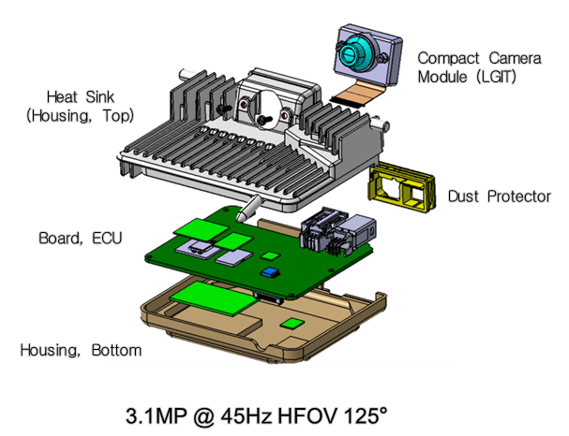
Figure 1-1 ADAS Front Mono Camera for MY20 C Class

Test Scope
The system area developed by LGE should be defined and explained as Test Scope.

Category | System Element | Test Scope | Description
HW | Camera | O | Developed by LGE
HW | Imager | X | Developed by Onsemi  The system elements developed by Onsemi are replaced with the test result reports for HW testing and tested from System Integration Testing Level
HW | AP (Sky runner) | X | Developed by NXP  The system element developed by NXP is replaced with the test result reports for HW testing and tested from System Integration Testing Level
HW | HuD Sensor | O | Developed by
SW | CPA, APTR - Object | X | Developed by LGE and Stradvision.  The system elements developed by Stradvision are replaced with the test result reports for SWUT and tested from Software Integration Testing Level
SW | LDP, LKA - Lane | O | Developed by LGE
SW | TSA - TSR | X | Developed by HAGL
SW | IHC - Light | X | Developed by HAGL
SW | QoS | O | Developed by LGE
SW | Calibration | O | Developed by LGE
SW | Virtual Map | O | Developed by LGE
SW | EVM | O | Developed by LGE
SW | OS (Green Hills) (TBD) | X | Developed by Green Hills  The system elements developed by Green Hills are replaced with the test result reports for SWUT and SWIT and tested from Software Qualification Testing Level
SW | AUTOSAR | X | Developed by Vector  The system elements developed by Vector are replaced with the test result reports for SWUT and SWIT and tested from Software Qualification Testing Level
Table 1-1 System Elements

Functionality
Define a function list at the level 1 of the FRP(Feature Release Plan) document

Feature | Description
Table 1-2 Features

Non-Functional Quality Attributes
Define the non-functional quality attributes based on the description and guide of ISO/IEC 25010

Characteristics | Subcharacteristics
Functional Suitability
Performance efficiency
Compatibility
Usability
Reliability
Security
Maintainability
Portability
Table 1-3 Quality Attributes

Risk Register
The risk related with the test should be identified from the predefined risk in the project.
If there is no predefined risk, do not write it as optional.

Project Risks
※ Risk = Likelihood × Impact
※ Likelihood : 1(Low), 2(Medium), 3(High) / Impact : 1(Low), 2(Medium), 3(High)
ID | Project Risk | Likelihood | Impact | Risk Score | Mitigation Activities
P1 | Lack of testing skills
P2 | Lack of human resources
P3 | Training issue
P4 | Low quality design
P5 | Delivery delay of Chipset, etc.
P6 | Lack of human resources (Supplier)
P7 | Not enough test schedule
P8 | Delay of establishing test environ.
P9 | Dalay of developing test data
P10 | …

Table 2-4 Project Risks

Product Risks
※ Risk = Likelihood × Impact
※ Likelihood : 1(Low), 2(Medium), 3(High) / Impact : 1(Low), 2(Medium), 3(High)
ID | Project Risk | Likelihood | Impact | Risk Score | Mitigation Activities
R1 | AAA (Complex Functionality)
R2 | BBB (Func. developed newly)
R3 | CCC (Func. w/ big code size)
R4 | DDD (Func. w/ high tech. difficulty)
R5 | EEE (Applying new technology)
R6 | FFF (Lack of development experience)
R7 | GGG (Func. w/ high ext. visibility)
R8 | HHH (Func. w/ sensitive safety issue)
R9 | III (Func. w/ high intensity – Light/Sound)
R10 | JJJ (Func. w/ high impact on reputation)
R11 | …

Table 2-5 Product Risks

Test Strategy
Write about system qualification test strategy.

A-SPICE PAM 3.0 document says that each development level requires each testing.
- System Qualification Testing for System Requirements
- System Integration Testing for System Architecture
- Software Qualification Testing for Software Requirements
- Software Integration Testing for Software Architecture
- Software Unit Verification for Software Detailed Design

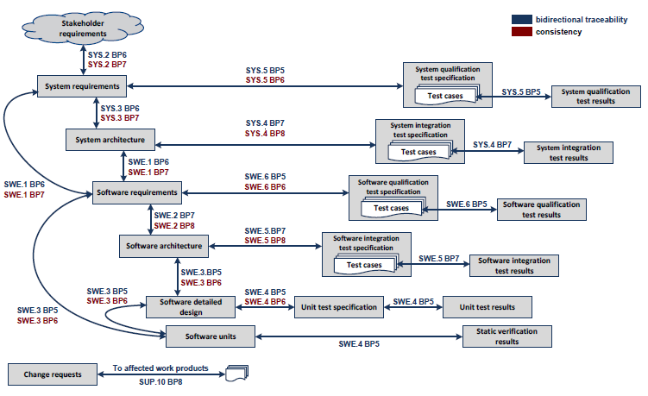
Figure 3-2. Bidirectional Traceability and Consistency of A-SPICE PAM 3.0

This project comply with A-SPICE test levels above.

The development schedule is composed of 9 releases, even though the goal is Release 7.
The duration of each iteration (release) would be as short as 3 months. Thus, Software Unit Verification should start and end at the same period of implementing. The basic testing of Software Integration is also done like SWUT. Then, 4 weeks are for testing the more specific Software Integration, Software Qualification, System Integration, and System Qualification, and 1 week for summarizing and reporting the test results.

Test Process
Write about system qualification test procedure.

The figure below depicts the testing overview of how to test.

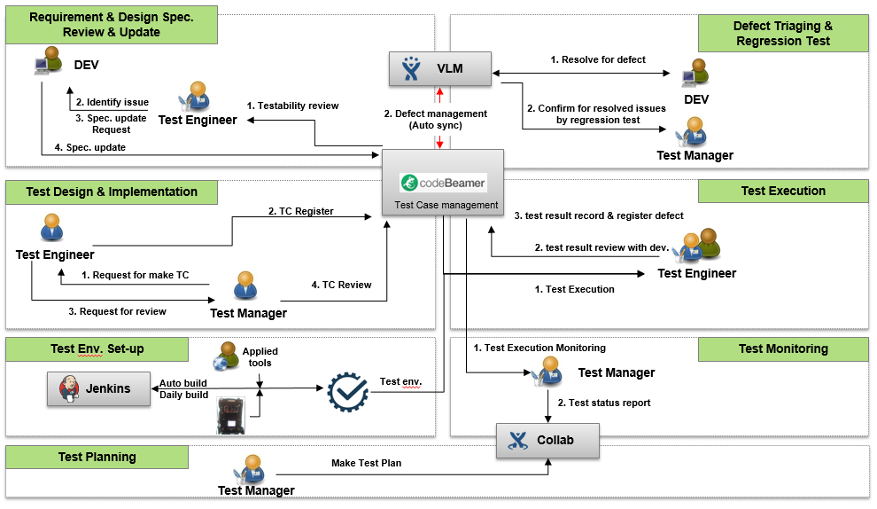
Figure 3-3. Test Process

Test Deliverables

Test Cases
Write the repository of system qualification test case.
http://val.lge.com/ivi/svn/DAI_MPC5_5/trunk/03_SW_Engineering/04_Test/06_System_Qualification_Test/02_System_Qualification_Test_Case

Test Results Report
Write the repository of system qualification test result report.
http://val.lge.com/ivi/svn/DAI_MPC5_5/trunk/03_SW_Engineering/04_Test/06_System_Qualification_Test/03_System_Qualification_Test_Report

Test Plan
Write the repository of system qualification test plan.
http://val.lge.com/ivi/svn/DAI_MPC5_5/trunk/03_SW_Engineering/04_Test/06_System_Qualification_Test/01_System_Qualification_Test_Plan

Reviews

Testability Review
Write the necessary processes, tools, and checklists for the Testability Review.
Write Review Techniques (Inspection, Walkthrough, Technical Review. Etc.) to be applied for engineering document review.
The figure below depicts the overview of revewing requirements testability.
Test Manager and tets engineers review the draft documents written by the development teams with the checklists.

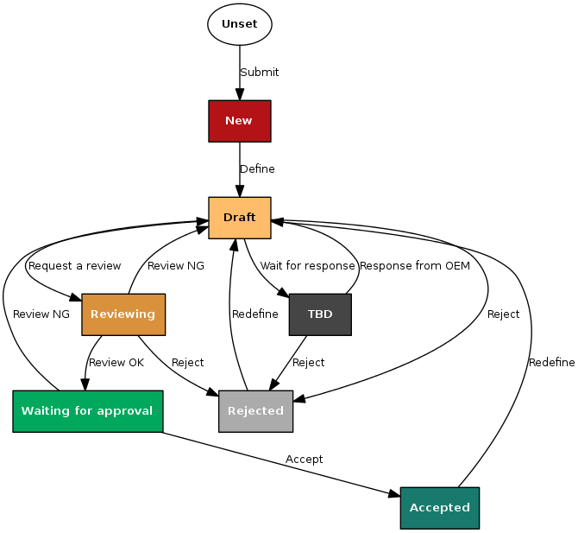
Figure 3-4. Requirements Testability Review

Test Case Conformity Review
Write the necessary processes, tools, and checklists for the Test Case Conformity Review.
Write Review Techniques (Peer Review. Etc.) to be applied for Test Case Conformity Review.

Test Design Techniques

Specification Based Testing
Write about specification based test techniques.

Test Technique | Applicable (Y or N) | Remarks
Equivalence Partitioning
Boundary Value Analysis
Decision Table Testing
State Transition Testing
Combinatorial Testing
Scenario Testing
Test Techniques of Specification-Based Testing

Test Technique | Applicable (Y or N) | Remarks
Equivalence Partitioning
Boundary Value Analysis
Decision Table Testing
State Transition Testing
Combinatorial Testing
Scenario Testing
Table 3-6 Test Techniques of Specification Based Testing

Equivalence Partitioning (Example)

Boundary Value Analysis (Example)

Experience Based Testing
Write about experience based test techniques.

Test Technique | Applicable (Y or N) | Remarks
Ad-hoc Testing
Exploratory Testing
Scripted Testing
Test Techniques of Experience-Based Testing

Test Technique | Applicable (Y or N) | Remarks
Ad-hoc Testing
Exploratory Testing
Scripted Testing
Table 3-7 Test Techniques of Experience Based Testing

Test Entry/Completion Criteria

Entry Criteria
Write about system qualification test entry criteria.

Entry Criteria
Completion of Testability Review and Test Case Design Review
Completion of Test Frame work
Software Code Freeze by Development Team
Completion of SW Unit Test
Table 3-8 Entry Criteria

Completion Criteria
Write about system qualification test completion criteria.

Completion Criteria
R1 | R2 | R3 | R4 | R5 | R6 | R7
 |  | 30% | 50% | 70% | 90% | 100%
Table 3-9 Completion Criteria

Metrics to be collected
See the Measurement Analysis Report in more detail (http://val.lge.com/ivi/svn/DAI_MPC5_5/trunk/02_Management/10_Quality_Measurement).

The Metrics of Measurement Analsysis
Write about metrics for system qualification test.

Statement Coverage (Example)

Statement Coverage
R1 | R2 | R3 | R4 | R5 | R6 | R7
 |  | 30% | 50% | 70% | 90% | 100%
Table 3-10 Metrics of Measurement Analysis

The Metrics of Test Cases Develoment Plan
Write about metrics for development plan of system qualification test cases.

Test Cases Development Plan
R1 | R2 | R3 | R4 | R5 | R6 | R7
 |  | 30% | 50% | 70% | 90% | 100%
Table 3-11 Metrics of Test Cases Develoment Plan

Retesting and Regression Testing
Write about the regression testing cycle(e.g. perform the regression test after retesting 3 times) and the retesting cycle.

Test Data
Write about system qualification test date.

Test Data | Description
Test data for data flow | used for each sequence diagram is separately defined
Input/Output data of Componet v | Input Data  Output Data
Table 3-12 Test Data

Test Environment Requirements
Write about system qualification test environment.

Test Tools

SW Testing Tools
Write about system qualification test tools.

Item | Description | Remark
Interface Testing | OS: Linux 64bit  Tool : Gerrit | Ver 2.13.7
Specification Basd Testing | OS: Ubuntu 14.04.5 LTS / ARCH = x64  Compiler : GCC 4.8.1
Structure Based Testing | OS: Ubuntu 14.04.5 LTS / ARCH = x64  Compiler : GCC 4.8.1
Experience Based Testing | OS: Ubuntu 14.04.5 LTS / ARCH = x64  Compiler : GCC 4.8.1
Table 3-13 Software Testing Tools

HW Testing Tools
Write about system qualification test tools for HW.

Item | Description | Remark
Interface Testing | OS: Linux 64bit  Tool : Gerrit | Ver 2.13.7
Specification Basd Testing | OS: Ubuntu 14.04.5 LTS / ARCH = x64  Compiler : GCC 4.8.1
Structure Based Testing | OS: Ubuntu 14.04.5 LTS / ARCH = x64  Compiler : GCC 4.8.1
Experience Based Testing | OS: Ubuntu 14.04.5 LTS / ARCH = x64  Compiler : GCC 4.8.1
Table 3-14 Hardware Testing Tools

Suspension and Resumption Criteria
Write about suspension and resumption criteria of system qualification test.

Step | Criteria
Suspension | Cases  - Source code and design output do not match or  - Source code have an issue  - Automated build system finds build issues. (commit scores -1)  In case of occurring critical or major defects enough to cause disruption in the overall test process, share the situation with the development PL and major stakeholders, conduct a meeting to determine whether to stop the test or not, and make a decision for the test suspention.
Resumption | Cases  - new patch-set with modified code.  Determine whether to resume testing through the stakeholders’ meeting after completing to fix major defects.
Table 3-15 Suspension/Resumption Criteria

Schedule
Write about system qualification test schedule.
If the schedule has already been defined on the Feature Release Plan or WBS in detail, refer to the relevant documents.

http://val.lge.com/ivi/svn/DAI_MPC5_5/trunk/02_Project Management/03_WBS/LGE_DAI_MPC5.5_WBS_v1.0.mpp

The workflow of the process is as below:

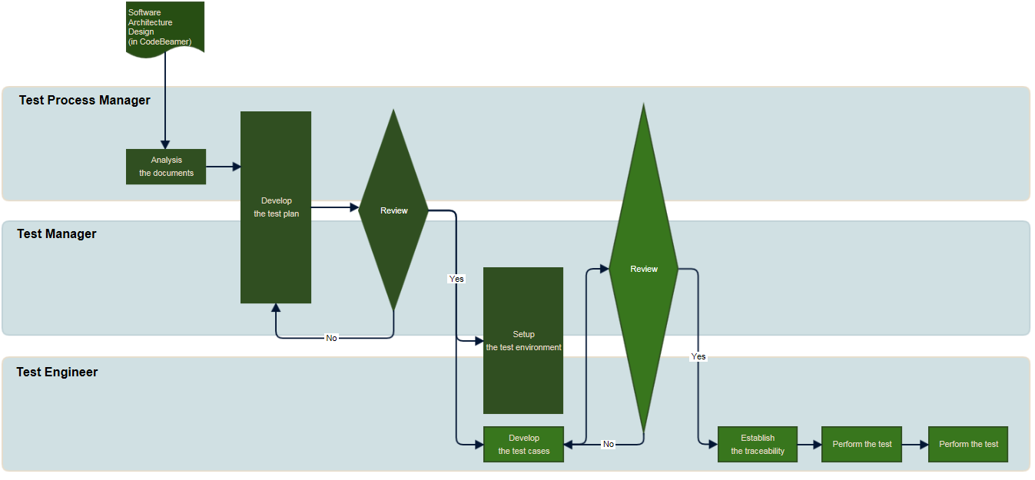
Figure 4-5. Workflow

Details can be found at the following URL.
http://collab.lge.com/main/display/DAIMPC/SWE.5+Workflow

SW Release Plan can be found at the following URL.
http://val.lge.com/ivi/svn/DAI_MPC5_5/trunk/02_ProjectManagement/00_Guide&milestone/02_Project Milestone/LGE_DAI_MPC5.5_SW_Release_Build_Plan_All_v1.0a.xlsx

